Sample Press Release to promote participation
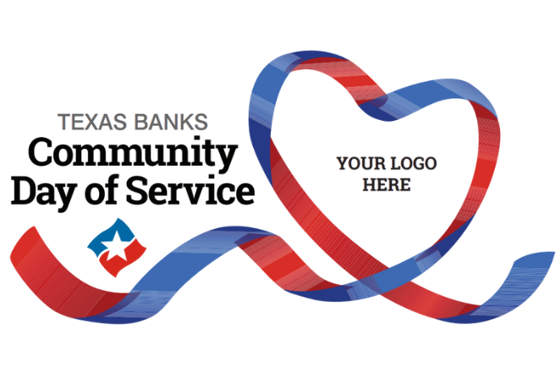

FOR IMMEDIATE RELEASE
Contact: [Your Name]
[Your Title]
[Bank Name]
[Phone Number]
[Email Address]
[Bank Website]
[BANK NAME] Participates in Statewide Day of Service to Support [TOWN/REGION] Community
[CITY, TEXAS] — [DATE] — On Monday, October 13, [Bank Name] will join banks across the state in giving back during this Day of Service, a statewide initiative organized by Texas Bankers to highlight the local impact of community banks.
Employees from [Bank Name] will volunteer their time and energy at [Name of nonprofit, school, or activity], helping to [brief description of activity—e.g., prepare meals, clean up a park, host a financial literacy session, etc.].
“We’ve always believed in being more than just a bank—we’re a neighbor, a partner, and a part of this community,” said [Bank President/CEO Name]. “This community focused Day of Service gives us a special opportunity to roll up our sleeves and make a difference alongside our customers and neighbors.”
This Day of Service brings together community banks across Texas to perform service projects of all kinds, reinforcing the role local banks play in strengthening the communities they serve.
[Optional quote from local partner nonprofit leader or city official.]
To follow along and see how banks are giving back across the state, visit [Bank’s social media] or search the hashtag #TXBanksDayofService.

About [Bank Name]
[1-2 sentence boilerplate about the bank—e.g., Founded in 1905, [Bank Name] is a locally owned community bank serving [region] with [#] locations across [counties/cities].]

